Bawaii Kattle
Characters index
(20090323)

SYMETRIE
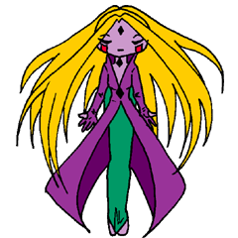 | Cuteness | 10
 | Strength | 6
 | Intelligence | 5
 | Wisdom | 10
 | Mana | 8
 | Special | Heal

DDT
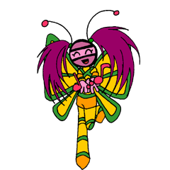 | Cuteness | 9
 | Strength | 5
 | Intelligence | 4
 | Wisdom | 8
 | Mana | 7
 | Special | Heal

HECATE
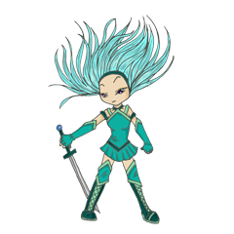 | Cuteness | 6
 | Strength | 7
 | Intelligence | 7
 | Wisdom | 5
 | Mana | 8
 | Special | Protect

LAVA
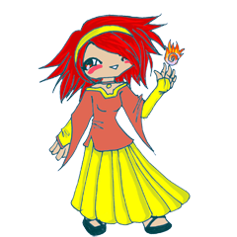 | Cuteness | 7
 | Strength | 8
 | Intelligence | 7
 | Wisdom | 5
 | Mana | 9
 | Special | Convert

GIZMO
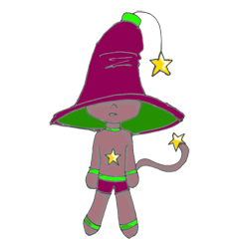 | Cuteness | 5
 | Strength | 4
 | Intelligence | 8
 | Wisdom | 10
 | Mana | 6
 | Special | Protect

ACTIVIUS
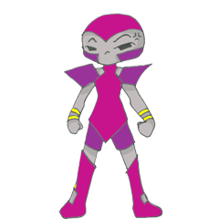 | Cuteness | 2
 | Strength | 9
 | Intelligence | 6
 | Wisdom | 3
 | Mana | 4
 | Special | Protect

BUBBLE
 | Cuteness | 1
 | Strength | 1
 | Intelligence | 2
 | Wisdom | 1
 | Mana | 10
 | Special | Reflect

NEKALE
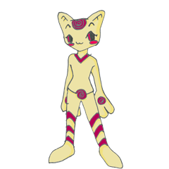 | Cuteness | 5
 | Strength | 6
 | Intelligence | 10
 | Wisdom | 9
 | Mana | 8
 | Special | Protect

MEGA BURGER
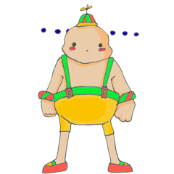 | Cuteness | 2
 | Strength | 7
 | Intelligence | 5
 | Wisdom | 1
 | Mana | 7
 | Special | Block

RODOLPHE
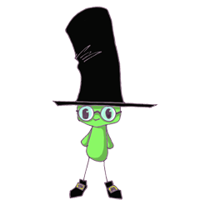 | Cuteness | 8
 | Strength | 2
 | Intelligence | 5
 | Wisdom | 10
 | Mana | 7
 | Special | Heal

AENAE
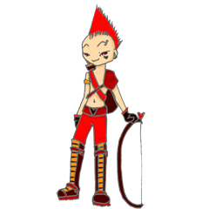 | Cuteness | 4
 | Strength | 6
 | Intelligence | 6
 | Wisdom | 7
 | Mana | 3
 | Special | Protect

NETOILE
 | Cuteness | 10
 | Strength | 5
 | Intelligence | 3
 | Wisdom | 4
 | Mana | 6
 | Special | Protect

LAURA
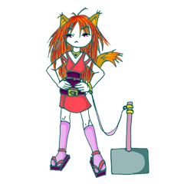 | Cuteness | 5
 | Strength | 7
 | Intelligence | 6
 | Wisdom | 6
 | Mana | 4
 | Special | Block

FLAOUA
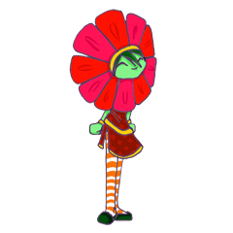 | Cuteness | 8
 | Strength | 3
 | Intelligence | 4
 | Wisdom | 10
 | Mana | 8
 | Special | Heal

CROSS
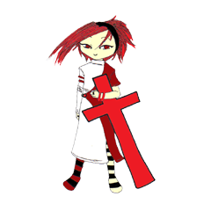 | Cuteness | 6
 | Strength | 8
 | Intelligence | 8
 | Wisdom | 10
 | Mana | 7
 | Special | Protect

EVIL FRAMBOISE
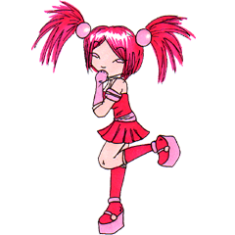 | Cuteness | 7
 | Strength | 7
 | Intelligence | 7
 | Wisdom | 5
 | Mana | 3
 | Special | Heal

ULTRAMARINE
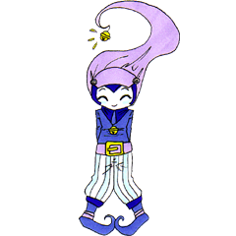 | Cuteness | 7
 | Strength | 7
 | Intelligence | 7
 | Wisdom | 4
 | Mana | 2
 | Special | Heal

MO
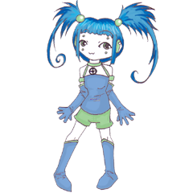 | Cuteness | 7
 | Strength | 7
 | Intelligence | 8
 | Wisdom | 5
 | Mana | 8
 | Special | Reflect

SHAMAN
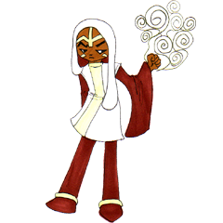 | Cuteness | 4
 | Strength | 8
 | Intelligence | 10
 | Wisdom | 7
 | Mana | 10
 | Special | Convert

SHIBUYA
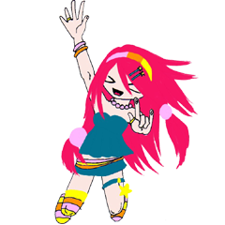 | Cuteness | 3
 | Strength | 4
 | Intelligence | 2
 | Wisdom | 4
 | Mana | 6
 | Special | Reflect

Character | C | S | I | W | M | Spe*
Symétrie | 10 | 6 | 5 | 10 | 8 | H
DDT | 9 | 5 | 4 | 8 | 7 | H
Hécate | 6 | 7 | 7 | 5 | 8 | P
Lava | 7 | 8 | 7 | 5 | 9 | C
Gizmo | 5 | 4 | 8 | 10 | 6 | P
Activius | 2 | 9 | 6 | 3 | 4 | P
Bubble | 1 | 1 | 2 | 1 | 10 | R
Nekale | 5 | 6 | 10 | 9 | 8 | P
Mega Burger | 2 | 7 | 5 | 1 | 7 | B
Rodolphe | 8 | 2 | 5 | 10 | 7 | H
Aenae | 4 | 6 | 6 | 7 | 3 | P
Nétoile | 10 | 5 | 3 | 4 | 6 | P
Laura | 5 | 7 | 6 | 6 | 4 | B
Flaoua | 8 | 3 | 4 | 10 | 8 | H
Cross | 6 | 8 | 8 | 10 | 7 | P
Evil Framboise | 7 | 7 | 7 | 5 | 3 | H
Ultramarine | 7 | 7 | 7 | 4 | 2 | H
Mo | 7 | 7 | 8 | 5 | 8 | R
Shaman | 4 | 8 | 10 | 7 | 10 | C
Shibuya | 3 | 4 | 2 | 4 | 6 | R

* H = Heal, P = Protect, C = Convert, R = Reflect, B = Block

